**NAME - BHASWANTH AYAPILLA**

**ID - 2020AAPS0304H**

1a.

Plot of HC-SR04 sensor data for stationary obstacle, at a distance of 26cm.

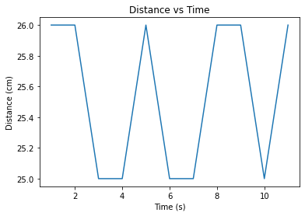

Plot of HC-SR04 sensor data for a constantly moving obstacle.

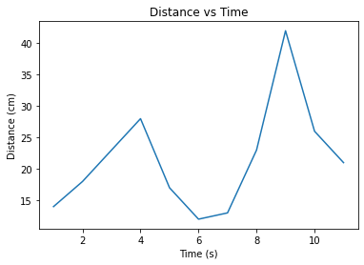

1b.

A grid is created to show the area of the map. The small circle at the bottom represents the position of the ultrasonic sensor.

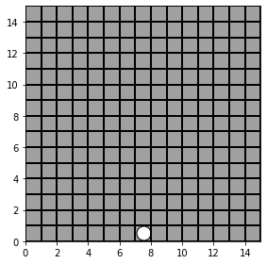

1c.

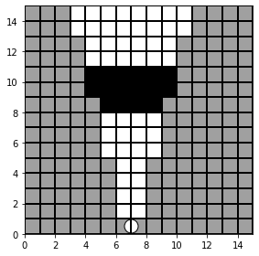

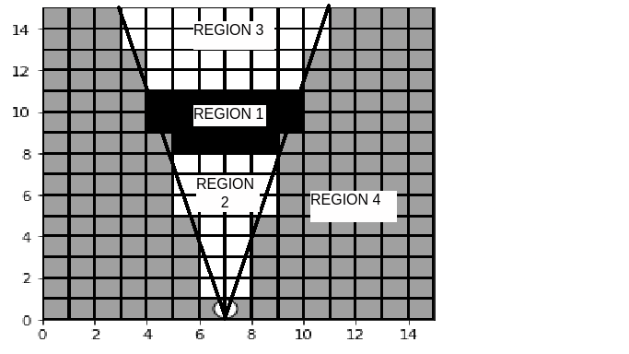

Reason for division of zones:

The reason for dividing the map into quadrants is to facilitate spatial analysis and navigation. By dividing the map into zones, you can focus on specific areas of interest and navigate more efficiently. In addition, it can help with object detection and avoidance, as you can concentrate on specific areas where obstacles are likely to be present.

Region 1: region with high probability of being occupied

Region 2: region with high probability of being empty

Region 3: region where probability of occurrence is unknown

Region 4: region of the environment that is unexplored

1d.

Grid plot with each grid having occupancy probability value.

1. Initialize the occupancy grid by setting all cells to the prior probability of occupancy, which is typically set to 0.5.
2. For each measurement within zones I and II, calculate the likelihood of the measurement given the occupancy of the corresponding grid cell using the Bayesian Sonar Sensor Model.
3. Update the probability of occupancy for each cell using Bayes' rule, where the prior probability is replaced by the updated probability.

